3el 2.3mtr 50Mhz Quad

DETAILS
Created: 21 February 2009
G0KSC SC0603Q 3el 50Mhz OWA Quad Antenna with a 2.266 Metre Length Boom
A nice short antenna at just 2.266 metres with almost 10dB of forward gain.. Over 9.44dBi has been achieved with excellent front to back ratio. This is around one metre less than would be required to see similar gain from a Yagi. In addition, I have been able to model the antenna without the narrow bandwidth characteristics normally associated with an antenna of this kind.
If Quads are your type of antenna, this one maybe for you.
As with all my antennas, this is a non-critical design and therefore, any small errors in you calculations when building the antenna WILL NOT have a great impact on the antennas final performance.
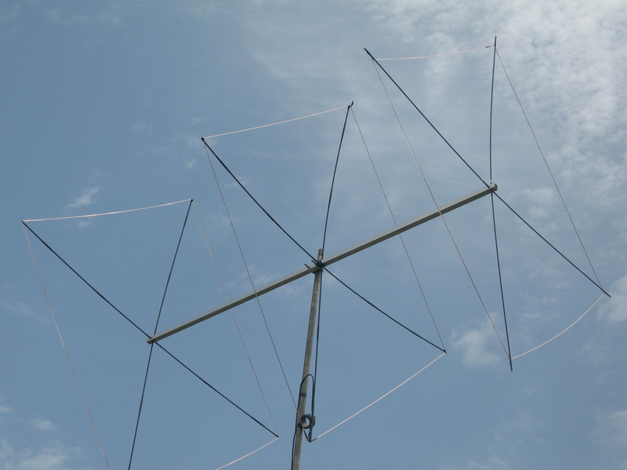
The 3el G0KSC 50MHz Quad at CT1QP
Dimensions in Metres
Element spacing:
- Ref = 0
- Driven = 1.212
- D1 = 2.266
Elements lengths - full quad length:
- Ref = 6.344
- Driven = 6.16
- D1 = 5.912
Performance figures @ 50.250Mhz:
- Froward Gain: 9.48dBi free space
- Front to Back: 37.13dB
- Radiation angle at 10 Metres above ground: 10 degrees

Element diameter:
This antenna has been models with 12# copper wire. You will need to mail me if you wish to use a different gauge as the model will change. Isolated spacers will be needed. fiberglass would be a good option.
NOTE:
Build orientation is as per the layout image below with the feed point on the bottom section of the quad indicated by a red circle.
Feeding the Antenna
Whilst OWA is not normally a term used in quad antennas, I felt it appropriate due to the low SWR and wide bandwidth of this antenna. Like all of my antennas, this has a 50Ohm impedance so can be fed directly with 50Ohm coax, no matching is required. However, a balun or RF chokes should be used in the coax as close to the feedpoint as possible.

